2. Basic Commands

Tasks

1. Open your Linux terminal and use the pwd, ls, and cd commands to navigate to your Downloads folder and list all files inside it.

ANS:

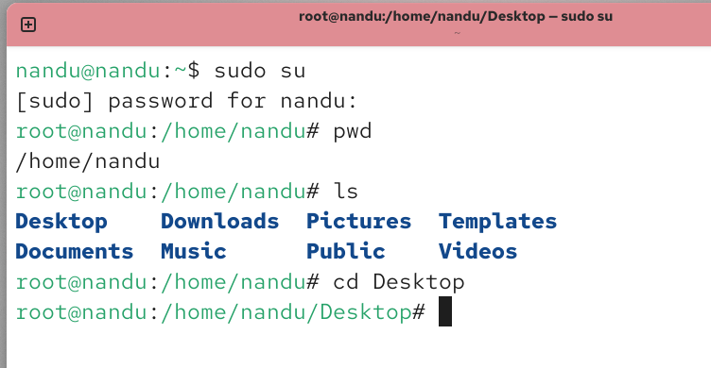

2. Create a new directory called 'music_playlist' inside your home directory using the mkdir command, then use the touch command to create three empty files named song1.mp3, song2.mp3, and song3.mp3 inside it.

ANS:

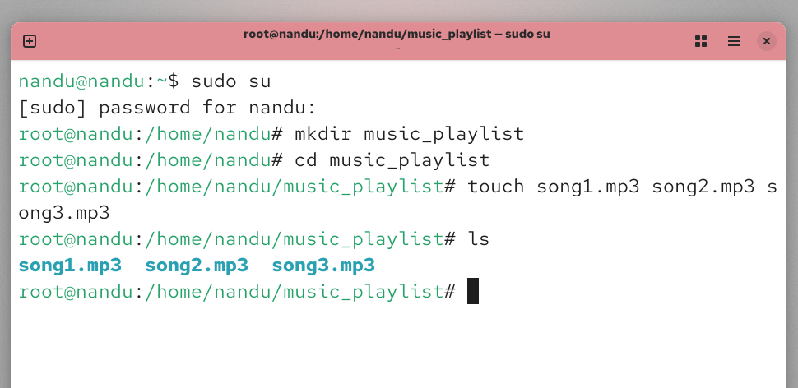

3. Use the cp command to copy all files from your 'music_playlist' directory to a new directory called 'backup_playlist', then use the ls command to verify the files were copied.

ANS:

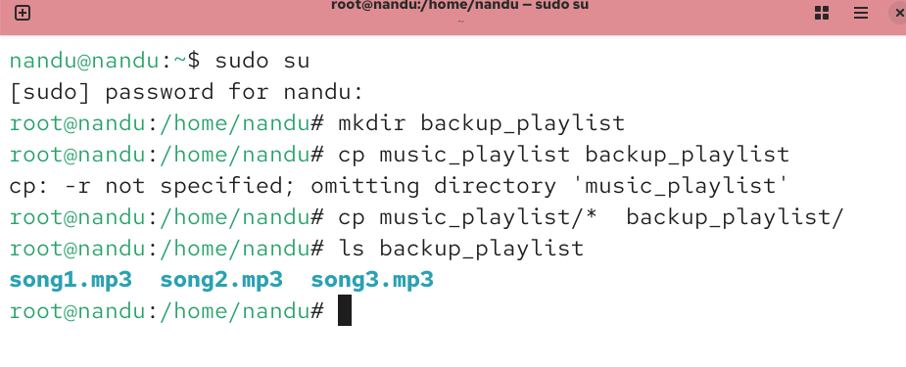

4. Use the mv command to rename 'song1.mp3' to 'favorite_song.mp3' inside the 'music_playlist' directory, and then use the rm command to delete 'song3.mp3' from the same directory.

ANS:

